**COMPUTE EC2:**

* Web service that enables to laugh and manage server instance.
* Instance available in different sizes and configuration.
* Use only the capacity you need and pay only what you use.
* Increase the capacity dynamically when the demand raises and vice versa.
* Supports both Vertical and Horizontal Scaling.
* Pre-built AMI available from market place.
* Have various pricing models like On-Demand, Spot and Reserved Instances.

**EBS-Elastic Block Storage**

* Provides high availability and highly reliable storage volumes.
* Suitable for database, file system or raw block storage.
* Created volume can attached to any EC2 instance.
* Multiple volumes can attach to one instance.
* Snapshot of the volume has to be taking for backup and sharing.

**Steps:**

The following are the steps for how to create, launch and connect to a server in AWS.

1. **Choose an Amazon Machine Image (AMI)**

An AMI is a template that contains the software configuration (operating system, application server and applications) required to launch your instance. We can select an AMI provided by AWS, our user community, or the AWS Marketplace, or we can select one of our own AMIs.

1. **Choose an Instance Type**

Amazon EC2 provides a wide selection of instance types optimized to fit different use cases. Instances are virtual servers that can run applications. They have varying combinations of CPU, memory, storage and networking capacity that give you the flexibility to choose the appropriate mix of resources for our applications.

1. **Configure Instance Details**

Configure the instance to suit our requirements and can launch multiple instances from the same AMI, request Spot instances to take advantage of the lower pricing, assign and access management role to the instance.

1. **Add Storage**

Instance will be launched with the storage device settings. We can attach additional EBS volumes and instance store volumes to our instance.

1. **Tag Instance**

A tag consists of a case-sensitive key-value pair.

1. **Configure Security Group**

A security group is a set of firewall rules that control the traffic of our instance. We can add rules to allow specific traffic to reach our instance.

1. **Review Instance Launch**

**Output:**

Server is created in AWS using EC2 and EBS is shown below.

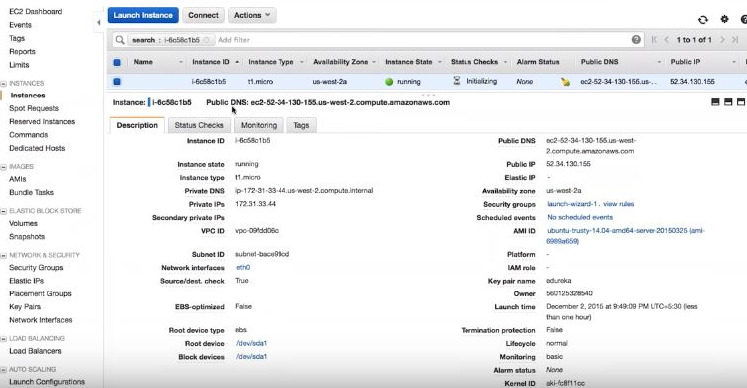

**Steps:**

The following are the steps involved in creating a load balancer.

1. Define Load Balancer
2. Assign Security Groups
3. Configure Security Settings
4. Configure Health Check
5. Add EC2 Instances
6. Add Tags
7. Review

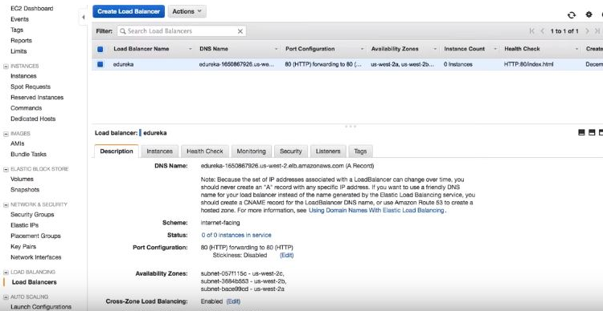

**Auto Scaling:**

Two steps to create Auto Scaling:

1. **Create launch configuration:**

In the launch configuration, we tell to Auto Scaling group what the machine needs to use whether to launch or not. Size of the server it may be Micro server or large server.

Choose AMI-> Choose Instance Type-> Configure details-> Add Storage-> Configure Security Group-> Review.

1. **Create Auto Scaling Group**

It is a group where you define the minimum or maximum and what servers will be added on what conditions and when it has to be removed.

Configure Auto Scaling group details-> Configure scaling policies-> Configure Notifications-> Configure Tags-> Review.

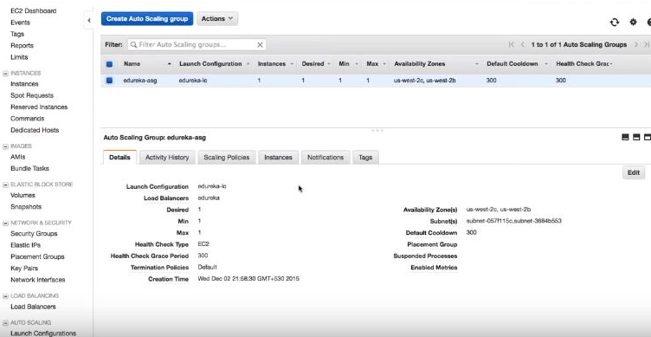

**RDS – Relational Database Service**

* Web Service that makes it easy to set up, operate and scale a relational database in cloud.
* Low-level database admin work is handled automatically by AWS.
* Supports PostgreSQL, MySQL, MSSQL and Oracle database.
* Amazon RDS automatically patches the database software.
* Backup the database for a user defined retention period.
* Enables point in time recovery.

**Output:**

